Nama : Tsaniya Faridah Maulida
NIM : 211331031
Kelas : 1A – Teknik Telekomunikasi

Elektronika Analog BAB 8 NO. 1-30

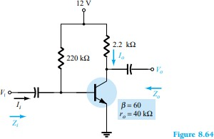
1.
For the network of Fig. 8.64:
- Determine 𝑍_{𝑖} and 𝑍_{𝑜}.
re : IB = 𝑉𝑐𝑐−𝑉𝐵𝐸 = 12 𝑉 − 0.7 𝑉 = 51.36 µA

𝑅𝐵
220𝐾 Ω
IE = ( ß + 1 ) IB = (60 + 1)(51.36 µA) = 3.13 mA

re = 26 𝑚𝑉 = 26 𝑚𝑉
= 8.31 Ω

𝐼𝐸 3.31 𝑚𝐴
Zi = RB || ßre = 220K Ω || (60)(8.31 Ω) = 220K Ω || 498.6 Ω = 497.47 Ω
ro ≥ 10Rc * Zo = Rc = 2.2K Ω
- Find 𝐴_{𝑣} and 𝐴_{𝑖}
Av = - 𝑅𝑐 = − 2.2𝐾 Ω = -264.74
𝑟𝑒 8.31 Ω
- Repeat part (a) with 𝑟_{𝑜} = 20 kΩ. Zi = 497.47 Ω
Zo = ro || Rc = 20K Ω || 2.2K Ω = 1.98K Ω
- Repeat part (b) with 𝑟_{𝑜} = 20 kΩ.
Av = −𝑅𝑐 ||𝑟𝑜 = −1.98𝐾 Ω = -238.27

𝑟𝑒
2.
8.31 Ω

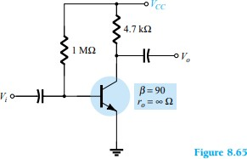
For the network of Fig. 8.65, determine 𝑉_{𝐶𝐶} for a voltage gain of 𝐴_{𝑣} = - 200.
Av = - ^{𝑅𝑐} →re = - ^{𝑅𝑐} = - ^{4.7𝐾} ^{Ω} = 23.5 Ω

𝑟𝑒
𝐴𝑣
−200

re = 26 𝑚𝑉 →IE = 26 𝑚𝑉 = 26 𝑚𝑉 = 1.106 Ma

𝐼𝐸
𝑟𝑒
23.5 Ω

IB = ^{𝐼𝐸}
= 1.106 𝑚𝐴 = 12.15 µA = IB = 𝑉𝑐𝑐−𝑉𝐵𝐸

ß+1 91 𝑅𝐵
Vcc = IBRB + VBE = (12.15 µA)(1M Ω) + 0.7 V = 12.15 V + 0.7 V = 12.85 V
3.

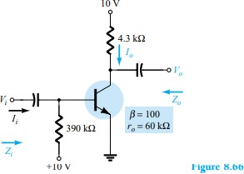
For the network of Fig. 8.66: (a) Calculate 𝐼_{𝐵,} 𝐼_{𝐶,} 𝑟_{𝑒}.
IB = 𝑉𝑐𝑐−𝑉𝐵𝐸 = 10 𝑉−0.7 𝑉 = 23.84 µA
𝑅𝐵 390𝐾 Ω
IE = (ß+1)IB=(101)(23.84 µA) = 2.40 mA

re = 26 𝑚𝑉 = 26 𝑚𝑉
= 13.76 Ω = IC = ßIB = (100)(23.84 µA) = 2.384 mA

𝐼𝐸 1.89 𝑚𝐴
- Determine 𝑍_{𝑖} and 𝑍_{𝑜}.
Zi = RB || ßre = 390K Ω || (100)(13.76 Ω) = 1.38K Ω
Ro ≥ 10Rc *Zo = Rc = 5.6K Ω
- Calculate 𝐴_{𝑣} and 𝐴_{𝑖}
Av = - 𝑅𝑐 = −5.6𝐾 Ω = -406.98
𝑟𝑒 13.76 Ω
- Determine the effect of 𝑟_{𝑜} = 30 kΩ on 𝐴_{𝑣} and 𝐴_{𝑖}.
Av = - 𝑅𝑐 ||𝑟0 = - (5.6𝐾 Ω)||(30𝐾 Ω) = - 4.72𝐾 Ω = -343.03

𝑟𝑒
4.
13.76 Ω
13.76 Ω

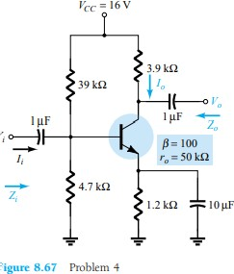
For the network of Fig. 8.67:
- Determine 𝑟_{𝑒}.
VB = 𝑅2 𝑉𝐶𝐶 = 4.7𝐾 Ω (16 𝑉) = 1.721 V
𝑅1+𝑅2 39𝐾 Ω+4.7𝐾 Ω
VE = VB-VBE = 1.721 V – 0.7 V = 1.021 V
IE = 𝑉𝐸 = 1.021 𝑉 = 0.8507 mA
𝑅𝐸 1,2𝐾 Ω

re = 26 𝑚𝑉 = 26 𝑚𝑉
= 30.56 Ω

𝐼𝐸 0.8507 𝑚𝐴
- Calculate 𝑍_{𝑖} and 𝑍_{𝑜}.
Zi = R1 || R2 || ßre = 4.7K Ω ||39K Ω || (100)930.56 Ω) = 1.77K Ω
ro ≥ 10Rc *Zo = Rc = 3.9K Ω
- Find 𝐴_{𝑣} and 𝐴_{𝑖}.
Av = - 𝑅𝑐 = - 3.9𝐾 Ω = -127.6
𝑟𝑒 30.56 Ω
- Repeat parts (b) and (c) with 𝑟_{𝑜} = 25 kΩ. Zi = 1.77K

Zo = Rc || ro = 3.9K Ω || 25K Ω = 3.37K Ω
Av = - (𝑅𝑐 ||𝑟0) = - (3.9𝐾 Ω)||(25𝐾 Ω) = - 3.37𝐾 Ω = -110.28

𝑟𝑒
5.
30.56 Ω
30.56 Ω

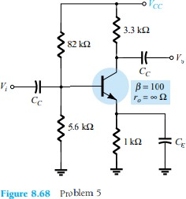
Determine 𝑉_{𝐶𝐶} for the network of Fig. 8.68 if 𝐴_{𝑣} = −160 and 𝑟_{𝑜} = 100 kΩ.
Av = = - ^{𝑅𝑐} = re = = - ^{𝑅𝑐} = = - ^{3.3𝐾} ^{Ω} = 20.625 Ω

𝑟𝑒
𝐴𝑣
−160

re = 26 𝑚𝑉 = IE = = - 26 𝑚𝑉 = 26 𝑚𝑉
= 1.261 mA

𝐼𝐸
𝑟𝑒
20.625 Ω

IE = ^{𝑉𝐸} = VE =IERE = (1.261 mA)(1K Ω) = 1.261 V
𝑅𝐸
VB = VBE + VE = 0.7 V + 1.261 V = 1.961 V

VB = 5.6𝐾 Ω 𝑉𝐶𝐶
5.6𝐾 Ω+82𝐾 Ω
= 1.961 V

5.6K Ω VCC = (1.961 V)(87.6K Ω) VCC = 30.68 V
6.
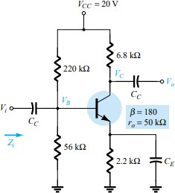
For the network of Fig. 8.69:
- Determine 𝑟_{𝑒}.
Rth = 56K Ω || 220K Ω = 44.64K Ω

Eth = 56𝐾 Ω (20 𝑉)
220𝐾 Ω+56𝐾 Ω
= 4.058 V

IB = 𝐸𝑡ℎ−𝑉𝐵𝐸
𝑅𝑡ℎ+(ß+1)𝑅𝐸
= 4.058 𝑉−0.7 𝑉 44.64𝐾 Ω+(181)(2.2𝐾 Ω)
= 7.58 µA

IE = (ß + 1)IB = (181)(7.58 µA) = 1.372 mA

re = 26 𝑚𝑉 = 26 𝑚𝑉
= 18.95 Ω

𝐼𝐸 1.372 𝑚𝐴
- Calculate 𝑉_{𝐵} and 𝑉_{𝐶}.
VE = IERE=(1.372 mA)(2.2K Ω) = 3.02 V VB = VE + VBE = 3.02 V + 0.7 V = 3.72 V
VC = VCC – ICRC = 20V – ßIBRC = 20 V – (180)(7.58 µA)(4.7K Ω) = 13.59 V

- Determine 𝑍_{𝑖}
and 𝐴_{𝑣}
= 𝑉𝑜
𝑉𝑖

Zi = R1 || R2 || ßre
= 56K Ω || 220K Ω || (180)(7.58 µA) = 44.64K Ω || 3.14K Ω = 3.17K Ω
ro < 10Rc

33.33K Ω < 10(4.7K Ω) = 47K Ω

Av = - 𝑅𝑐 ||𝑟0 = - (6.8𝐾 Ω)||(50𝐾 Ω)
= -298.15

𝑟𝑒
7.
18.95 Ω

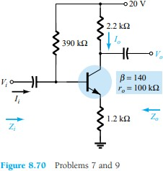

For the network of Fig. 870 :
- Determine 𝑟_{𝑒}.
𝑉𝐶𝐶 − 𝑉𝐵𝐸

20 𝑉 − 0.7 𝑉

19.3 𝑉

𝐼_{𝐵} =
𝑅
𝐵
+ (𝛽 + 1)𝑅_{𝐸}
= = = 34.51µ𝐴
390 𝑘Ω + (141)(1.2 𝑘Ω) 559.2 𝑘Ω

𝐼_{𝐸} = (𝛽 + 1)𝐼_{𝐵} = (140 + 1)(34.51µ𝐴) = 4.866𝑚𝐴

𝑟_{𝑒} =
26 𝑚𝑉

𝐼_{𝐸}
26 𝑚𝑉
= = 𝟓. 𝟑𝟒 Ω 4.866𝑚𝐴

- Find 𝑍_{𝑖} and 𝑍_{𝑜}.
𝑍_{𝑏} = β𝑟_{𝑒} + (β + 1)𝑅_{𝐸} = (140)(5.34 𝑘Ω) + (140 + 1)(1.2 𝑘Ω) = 747.6 = 169.95 𝑘Ω
𝑍_{𝑖} = 𝑅_{𝐵}|| 𝑍_{𝑏} = 390𝑘Ω||169.95 k Ω = 118.37 kΩ = 𝑅_{𝐶} = 𝟐. 𝟐 𝒌Ω
- Calculate 𝐴_{𝑣} and 𝐴_{𝑖}.
𝐴 = - 𝛽𝑅𝑐 = - (140)(2.2 𝐾Ω) = -1.81

𝑣 𝑍𝑏
169.95 𝐾Ω

- Repeat parts (b) and (c) with 𝑟_{𝑜} = 20 kΩ.
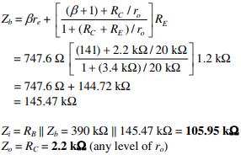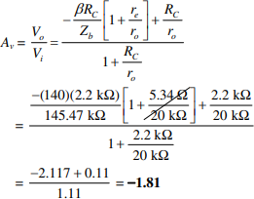
8.
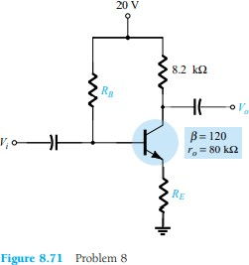
For the network of Fig. 8.71, determine 𝑅_{𝐸} and 𝑅_{𝐵} if 𝐴_{𝑣} = − 10 and 𝑟_{𝑒} = 3.8Ω. Assume that
𝑍_{𝑏} = 𝛽𝑅_{𝐸}.

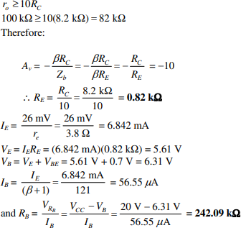
- Repeat Problem 7 with 𝑅_{𝐸} bypassed. Compare results.
  - dc analysis the same = 𝑟_{𝑒} = 5.34 Ω

= - 𝑅𝑐 = - 2.2 𝐾Ω = -411.99

𝑣

𝑟𝑒
5.34 Ω

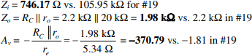
- 10.
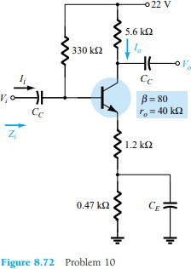

For the network of Fig. 872 :
  - Determine 𝑟_{𝑒}.
𝑉𝐶𝐶 − 𝑉𝐵𝐸

22 𝑉 − 0.7 𝑉

21.3 𝑉

𝐼_{𝐵} =
𝑅
𝐵
+ (𝛽 + 1)𝑅_{𝐸}
= = = 45.78µ𝐴
330 𝑘Ω + (81)(1.2 𝑘Ω + (0.47 𝑘Ω)) 465.27 𝑘Ω

𝐼_{𝐸} = (𝛽 + 1)𝐼_{𝐵} = (81)(45.78µ𝐴) = 3.71𝑚𝐴

𝑟_{𝑒} =
26 𝑚𝑉

𝐼_{𝐸}
26 𝑚𝑉
= = 𝟕 Ω
3.71𝑚𝐴

  - Find 𝑍_{𝑖} and 𝐴_{𝑣.}

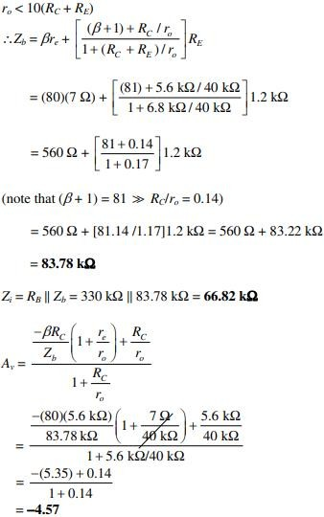
- 11.
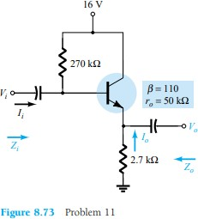

For the network of Fig. 873 :
  - Determine 𝑟_{𝑒} and 𝛽𝑟_{𝐸}.
𝑉𝐶𝐶 − 𝑉𝐵𝐸

16 𝑉 − 0.7 𝑉

15.3 𝑉

𝐼_{𝐵} =
𝑅
𝐵
+ (𝛽 + 1)𝑅_{𝐸}
= = = 26.86µ𝐴
270 𝑘Ω + (111)(2.7 𝑘Ω) 569.7 𝑘Ω

𝐼_{𝐸} = (𝛽 + 1)𝐼_{𝐵} = (110 + 1)(26.86µ𝐴) = 2.98 𝑚𝐴

𝑟 = 26 𝑚𝑉 = 26 𝑚𝑉

= 𝟖. 𝟕𝟐 Ω = 𝛽𝑟
= (110)(8.72 Ω) = 𝟗𝟓𝟗. 𝟐 Ω

𝑒 𝐼𝐸
2.98 𝑚𝐴 𝑒

  - Find 𝑍_{𝑖} and 𝑍_{𝑜.}
𝑍_{𝑏} = β𝑟_{𝑒} + (β + 1)𝑅_{𝐸} = 959.2 Ω + (111)(2.7 𝑘Ω) = 747.6 = 300.66 𝑘Ω
𝑍_{𝑖} = 𝑅_{𝐵}|| 𝑍_{𝑏} = 270 𝑘Ω||300.66 k Ω = 142.25 kΩ
𝑍_{𝑜} = 𝑅_{𝐸}|| 𝑟_{𝑒} = 2.7 𝑘Ω||8.72 Ω = 8.69 Ω
  - Calculate 𝐴_{𝑣} and 𝐴_{𝑖}.
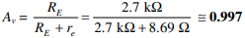

- 12.
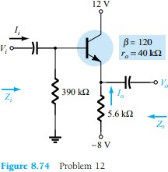

For the network of Fig. 874 :
  - Determine 𝑍_{𝑖} and 𝑍_{𝑜.}
𝑉𝐶𝐶 − 𝑉𝐵𝐸

8 𝑉 − 0.7 𝑉

𝐼_{𝐵} =
𝑅
𝐵
+ (𝛽 + 1)𝑅_{𝐸}
= = 6.84µ𝐴
390 𝑘Ω + (121)(5.6 𝑘Ω)

𝐼_{𝐸} = (𝛽 + 1)𝐼_{𝐵} = (121)(6.84µ𝐴) = 0.828 𝑚𝐴

𝑟 = 26 𝑚𝑉 = 26 𝑚𝑉

= 31.4 Ω →
< 10𝑅
= 𝑍
= 598.16 𝑘Ω

𝑒 𝐼𝐸

0,828 𝑚𝐴
𝑜 𝐸 𝑏

𝑍_{𝑖} = 𝑅_{𝐵}|| 𝑍_{𝑏} = 390 𝑘Ω||598.16 k Ω = 236.1 kΩ
𝑍_{𝑜} = 𝑅_{𝐸}|| 𝑟_{𝑒} = 5.6 𝑘Ω||3.14 Ω = 31.2 Ω
  - Find 𝐴_{𝑣.}
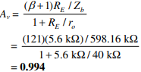
  - Calculate 𝑉_{𝑜} if 𝑉_{𝑖} = 1 mV.
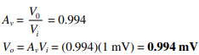
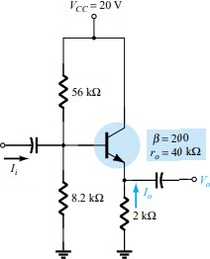
- 13.
For the network of Fig. 875 :
  - Calculate 𝐼_{𝐵} and 𝐼_{𝐶.}

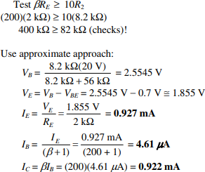

  - Determine 𝑟_{𝑒.}
26 𝑚𝑉

26 𝑚𝑉

𝑟_{𝑒} =
𝐼_{𝐸}
= = 𝟐𝟖. 𝟎𝟓 Ω 0,927 𝑚𝐴

  - Determine 𝑍_{𝑖} and 𝑍_{𝑜.}
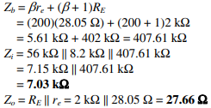
  - Find 𝐴_{𝑣} and 𝐴_{𝑖}.
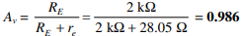
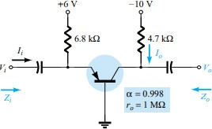
- 14.
For the common-base configuration of Fig. 8.76:
  - Determine 𝑟_{𝑒.}

𝐼_{𝐸} =
𝑉𝐸𝐸 − 𝑉𝐵𝐸

𝑅_{𝐸}
6 𝑉 − 0.7 𝑉
= = 0.779𝑚 6.8 𝑘Ω)

𝑟_{𝑒} =
26 𝑚𝑉

𝐼_{𝐸}
26 𝑚𝑉
= = 𝟑𝟑. 𝟑𝟖 Ω 0,779 𝑚𝐴

  - Find 𝑍_{𝑖} and 𝑍_{𝑜.}
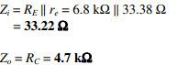
  - Calculate 𝐴_{𝑣} and 𝐴_{𝑖}.

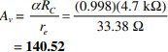
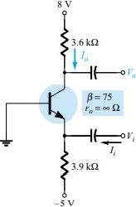
- 15.
For the network of Fig. 8.77, determine 𝐴_{𝑣} and 𝐴_{𝑖}.
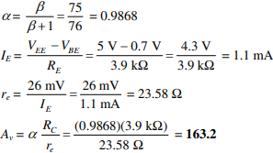
- 16.
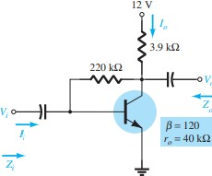
For the collector FB configuration of Fig. 8.78:
  - Determine 𝑟_{𝑒}

𝐼 = 𝑉𝐶𝐶− 𝑉𝐵𝐸 = 12 𝑉−0.7
= 16.42µ𝐴

𝐵 𝑅𝐹+ 𝛽𝑅𝐶 220𝑘Ω+120(3.9𝑘Ω)
𝐼_{𝐸} = (𝛽 + 1)𝐼_{𝐵} = (120 + 1)(16.42µ𝐴) = 1.987𝑚𝐴

𝑟_{𝑒} =
26 𝑚𝑉

𝐼_{𝐸}
26 𝑚𝑚𝑉
= = 𝟏𝟑. 𝟎𝟖 Ω 1.987𝑚𝐴

  - Find 𝑍_{𝑖} and 𝑍_{𝑜}
𝑅_{𝐹}
𝑍_{𝑖} = 𝛽𝑟_{𝑒}||
𝐴
𝑣

𝐴_{𝑣} =
−𝑅_{𝐶}

𝑟_{𝑒}
−3.9 𝑘Ω
= = −298 13.08Ω

𝑍_{𝑖}
= (120)(13.08Ω) || ^{220𝑘Ω} = 1.5696 𝑘Ω||738Ω = 𝟓𝟎𝟏. 𝟗𝟖 Ω
298

𝑍_{𝑜} = 𝑅_{𝐶}|| 𝑅_{𝐹} = 3.9 𝑘Ω || 220kΩ = 3.83 kΩ
  - Calculate 𝐴_{𝑣} and 𝐴_{𝑖}
From above, 𝐴_{𝑣} = −𝟐𝟗𝟖
- 17.

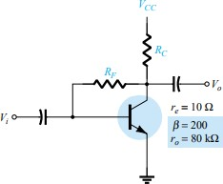
Given 𝑟_{𝑒.} = 10Ω, β = 200, 𝐴_{𝑣} = - 160, and 𝐴_{𝑖}= 19 for the network of Fig. 8.79, determine
𝑅𝐶, 𝑅𝐹, and 𝑉𝐶𝐶.

𝐴_{𝑣}
= −𝑅𝐶 = - 160
𝑟𝑒

𝑅_{𝐶} = 160(𝑟_{𝑒}) = 160(10Ω) = 1.6 kΩ

𝐴 = 𝛽𝑅𝐹 = 19 → 19 = 200𝑅𝐹 = 𝑅
= 3800𝑅𝐶 = 3800(1.6 kΩ) = 𝟑𝟑. 𝟓𝟗 kΩ

𝑖 𝑅𝐹+ 𝛽𝑅𝐶
𝐼 = 𝑉𝐶𝐶−𝑉𝐵𝐸 = 𝐼

(𝑅

+ 𝛽𝑅
𝑅𝐹+200(1.6 𝑘Ω)
) = 𝑉
𝐹

and 𝑉
181
= 𝑉

+ 𝐼
181
(𝑅

+ 𝛽𝑅 )

𝐵 𝑅𝐹+𝛽𝑅𝐶
𝐵 𝐹 𝐶
𝐶𝐶−𝑉𝐵𝐸
𝐶𝐶
𝐵𝐸
𝐵 𝐹 𝐶

with 𝐼 = 26 𝑚𝑉 = 26 𝑚𝑉 = 2.6 𝑚𝐴 → 𝐼

= 𝐼𝐸
= 2.6𝑚𝐴 = 12.94 µ𝐴

𝐸 𝑟𝑒
10Ω
𝐵 𝛽+1
200+1

∴ 𝑉_{𝐶𝐶} = 𝑉_{𝐵𝐸} + 𝐼_{𝐵}(𝑅_{𝐹} + 𝛽𝑅_{𝐶}) = 0.7 𝑉 + (12.94 µ𝐴)(33.59 𝑘Ω + (200)(1.6 𝑘Ω))
= 𝟓. 𝟐𝟖 𝑽
- For the network of Fig. 8.30:
  - Derive the approximate equation for 𝐴_{𝑣.}
𝐴_{𝑣} : 𝑉_{𝑖} = 𝐼_{𝑏}𝛽𝑟_{𝑒}+ (β+1) 𝐼_{𝑏}𝑅_{𝐸}
𝐼_{𝑜} + 𝐼′ = 𝐼_{𝐶} = 𝛽𝐼_{𝑏}, but 𝐼_{𝑖} = 𝐼′ + 𝐼_{𝑏} and 𝐼′ = 𝐼_{𝑖} − 𝐼_{𝑏}
Substituting, 𝐼_{𝑜} + (𝐼_{𝑖} − 𝐼_{𝑏}) = 𝛽𝐼_{𝑏} and 𝐼_{𝑜} = (𝛽 + 1)𝐼_{𝑏} − 𝐼_{𝑖}
Assuming (𝛽 + 1)𝐼_{𝑏} ≫ 𝐼_{𝑖} → 𝐼_{𝑜} ≅ (𝛽 + 1)𝐼_{𝑏} and 𝑉_{𝑜} = − 𝐼_{𝑜} 𝑅_{𝐶} = −(𝛽 + 1)𝐼_{𝑏}𝑅_{𝐶}

Therefore, 𝑉𝑜 = −(𝛽+1)𝐼𝑏𝑅𝐶 and
= 𝑉𝑜 ≅ − 𝑅𝐶 = − 𝑹𝑪

𝑉𝑖
𝐼𝑏𝛽𝑅𝐸+(𝛽+1)𝐼𝑏𝑅𝐸
𝑣 𝑉𝑖
𝑟𝑒+𝑅𝐸
𝑹𝑬

  - Derive the approximate equation for 𝐴_{𝑖}.
  - Derive the approximate equations for 𝑍_{𝑖} and 𝑍_{𝑜.}

𝑉 ≅ 𝛽𝐼 (𝑟 + 𝑅 ) for 𝑟 ≪ 𝑅 → 𝑉 ≅ 𝛽𝐼 𝑅 → Now 𝐼
+ 𝐼′ +
= 𝑉𝑖−𝑉𝑜 + 𝐼

𝑖 𝑏 𝑒 𝐸
𝑒 𝐸 𝑖
𝑏 𝐸 𝑖
𝑏 𝑅𝐹 𝑏

Since 𝑉 ≫ 𝑉 → 𝐼
= − 𝑉𝑜 + 𝐼 or 𝐼
= 𝐼 + 𝑉𝑜 and 𝑉 = 𝛽𝑅
𝐼 + 𝛽 𝑉𝑜 𝑅 but 𝑉
= 𝐴 𝑉

𝑜 𝑖 𝑖
𝑅𝐹 𝑏 𝑏
𝑖 𝑅𝐹 𝑖
𝐸 𝑖
𝑅𝐹 𝐸
𝑜 𝑣 𝑖

and 𝑉

= 𝛽𝑅
𝐼 + 𝛽𝐴𝑣𝑉𝑖𝑅𝐸

or 𝑉 − 𝐴𝑣𝛽𝑅𝐸𝑉𝑖 = 𝛽𝑅 𝐼 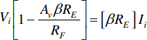

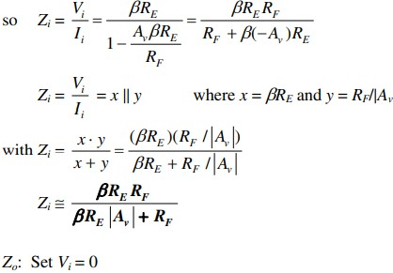
𝑖 𝐸 𝑖
𝑅𝐹
𝑖 𝑅𝐹
𝐸 𝑖

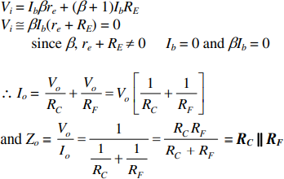
(d) Given 𝑅_{𝐶} = 2.2kΩ, 𝑅_{𝐹} = 120 kΩ, 𝑅_{𝐸} = 1.2 kΩ, β = 90, and 𝑉_{𝐶𝐶} = 10 V, calculate the magnitudes of 𝐴_{𝑣}, 𝐴_{𝑖}, 𝑍_{𝑖} and 𝑍_{𝑜} using the equations of parts (a) through (c).
𝐴 ≅ − 𝑅𝐶 = - ^{2.2𝑘Ω} = −𝟏. 𝟖𝟑

𝑣 𝑅𝐸
1.2𝑘Ω

𝑍 ≅ 𝛽𝑅𝐸𝑅𝐹 = (90)(1.2𝑘Ω)(120𝑘Ω)
= 40.8 kΩ

𝑖 𝛽𝑅𝐸|𝐴𝑉|+𝑅𝐹 (90)(1.2𝑘Ω)(1.83)+120𝑘Ω
𝑍_{𝑜} ≅ 𝑅_{𝐶}|| 𝑅_{𝐹} = 2.2𝑘Ω|| 120kΩ = 2.16 kΩ
- 19.
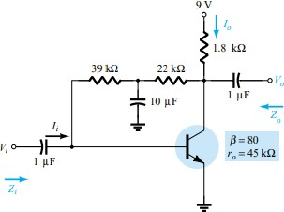

For the network of Fig. 8.80:
  - Determine 𝑍_{𝑖} and 𝑍_{𝑜.}
𝑉𝐶𝐶 − 𝑉𝐵𝐸

9 𝑉 − 0.7 𝑉

8.3 𝑣

8.3 𝑉

𝐼_{𝐵} =
𝑅
𝐹
+ 𝛽𝑅_{𝐶}
= =
(39 𝑘Ω + 22𝑘Ω)(80)(1.8 𝑘Ω)
=
61 𝑘Ω + 144 𝑘Ω 205 𝑘Ω

= 40.49 µ𝐴
𝐼_{𝐸} = (𝛽 + 1)𝐼_{𝐵} = (80 + 1)(40.49 µ𝐴) = 3.28 𝑚𝐴

𝑟_{𝑒} =
26 𝑚𝑉

𝐼_{𝐸}
26 𝑚𝑉
= = 7.93 Ω
3.28 𝑚𝐴

𝑍_{𝑖} = 𝑅_{𝐹𝑖}|| 𝛽𝑟_{𝑒} = 39 kΩ || (80)(7.93 Ω)= 39 kΩ || 634.4 Ω = 0.62 kΩ
𝑍_{𝑜} = 𝑅_{𝐶}|| 𝑅_{𝐹2} = 1.8 𝑘Ω|| 22 kΩ = 1.66 kΩ
  - Find 𝐴_{𝑣} and 𝐴_{𝑖}.
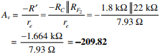
- (a) Given β = 120, 𝑟_{𝑒} = 4.5Ω and 𝑟_{𝑜} = 40kΩ, sketch the approximate hybrid equivalent circuit.
ℎ_{𝑓𝑒} = β = 120
ℎ_{𝑖𝑒} ≅ β𝑟_{𝑒} = (120)( 4.5Ω) = 540 Ω

ℎ𝑜𝑒
= 1
𝑟𝑜
= 1
40 𝑘Ω
= 𝟐𝟓 µS

(b) Given ℎ_{𝑖𝑒}= 1 kΩ, ℎ_{𝑟𝑒} = 2 × 10⁻⁴, ℎ_{𝑓𝑒} = 90, 𝑎𝑛𝑑 ℎ_{𝑜𝑒} = 20µ𝑆, skecth the 𝑟_{𝑒} model.
𝑟 ≅ ℎ𝑖𝑒 = 1𝑘Ω = 11.11 Ω

𝑒 𝛽 90
𝛽 = ℎ_{𝑓𝑒} = 90

𝑟_{𝑜}
= 1
ℎ𝑜𝑒
= 1
20 µS
= 𝟓𝟎 𝒌Ω

- For the network of Problem 1:

  - Determine 𝑟_{𝑒} = 𝟖. 𝟑𝟏 Ω
(b) ℎ_{𝑓𝑒} = β = 60
ℎ_{𝑖𝑒} = β𝑟_{𝑒} = (60)( 8.31 Ω) = 498.6 Ω
- Find 𝑍_{𝑖} and 𝑍_{𝑜.} using the hybrid parameters.
𝑍_{𝑖} = 𝑅_{𝐵}|| ℎ_{𝑖𝑒} = 220 kΩ || 498.6 Ω = 497.47 Ω
𝑍_{𝑜} = 𝑅_{𝐶} = 𝟐. 𝟐 𝒌Ω
- Calculate 𝐴_{𝑣} and 𝐴_{𝑖} using the hybrid parameters.
𝐴 = −ℎ𝑓𝑒𝑅𝐶 = −(60)(2.2𝑘Ω) = -264.74

𝑣 ℎ𝑖
498.6 Ω

𝐴_{𝑖} ≅ ℎ_{𝑓𝑒} = 60
- Determine 𝑍_{𝑖} and 𝑍_{𝑜} If ℎ_{𝑜𝑒} = 50 µS.
𝑍_{𝑖} = 𝟒𝟗𝟕. 𝟒𝟕 Ω (𝑡ℎ𝑒 𝑠𝑎𝑚𝑒)
𝑍 = 𝑟 || 𝑅 , 𝑟 = ¹ = 40 𝑘Ω → 40 𝑘Ω || 2.2 𝑘Ω = 2.09 𝒌Ω

𝑜 𝑜
𝐶 𝑜
25 µ𝑆

- Determine 𝐴_{𝑣} and 𝐴_{𝑖} If ℎ_{𝑜𝑒} = 50 µS.
𝐴 = −ℎ𝑓𝑒(𝑟𝑜||𝑅𝐶) = −(60)(2.085 𝑘Ω) = -250.90

𝑣

𝐴_{𝑖} = −
ℎ𝑖𝑒
𝐴_{𝑣}𝑍_{𝑖}

𝑅_{𝐶}
498.6 Ω
(−250.90)(497.47Ω)
= − = 𝟓𝟔. 𝟕𝟑
2.2 𝑘Ω

- Compare the solutions above with those of Problem 1. (Note: The solutions are available in Appendix E if Problem 1 was not performed.)
- 22.
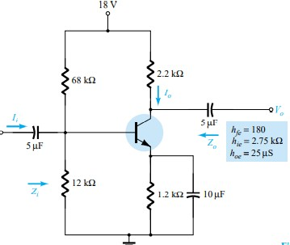
For the network of Fig. 8.81 :
  - Determine 𝑍_{𝑖} and 𝑍_{𝑜.}
68 kΩ || 12 kΩ = 10.2 kΩ
𝑍_{𝑖} = 10.2 kΩ || ℎ_{𝑖𝑒} = 10.2 kΩ || 2.75 kΩ = 2.166 kΩ
𝑍_{𝑂} = RC || 𝑟_{𝑜} = 2.2 kΩ || 40 kΩ = 2.085 kΩ
  - Calculate 𝐴_{𝑣} and 𝐴_{𝑖}.

𝐴_{𝑣}
= −ℎ𝑓𝑒𝑅′𝐶 → 𝑅′
ℎ𝑖𝑒
𝐶
= 𝑅_{𝐶}
|| 𝑟_{𝑜}
= 2.085 𝑘Ω

= −(180)(2.085 𝑘Ω) = -136.5
2.75 𝑘Ω
𝐴 = 𝐼𝑂 = 𝐼𝑂 × 𝐼′𝑖 = 135.13

𝑖 𝐼𝑖
𝐼′𝑖
𝐼𝑖

  - Determine 𝑟_{𝑒}and β𝑟_{𝑒} to ℎ_{𝑖𝑒.}
- 23.
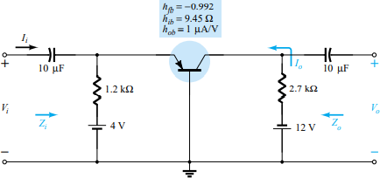
For the common-base network of Fig. 8.82:

(a) Deterime 𝑍_{𝑖} = 𝑅_{𝐸} || ℎ_{𝑖𝑏} = 1.2 kΩ || 9.45 Ω = 9.38 Ω

𝑍_{𝑜}
= 𝑅_{𝐶}
|| ¹ ℎ𝑖𝑏
= 2.7 kΩ || ¹ 1×10−6𝐴/𝑉
= 2.7 kΩ || 1 MΩ ≅ 2.7 kΩ

(b) 𝐴_{𝑣} =
−ℎ𝑓𝑏(𝑅𝐶 || 1 )
ℎ𝑎𝑏
ℎ𝑖𝑏
= −(−0.992)(≅2.7 kΩ) = 𝟐𝟖𝟒. 𝟒𝟑
9.45
Ω

𝐴_{𝑖} ≅ −𝟏
(c) Determine α, β, 𝑟_{𝑒}and 𝑟_{𝑜}.
α = −ℎ_{𝑓𝑏} = −(−0.992) = 𝟎. 𝟗𝟗𝟐

β = ^{𝛼} 1−𝛼
= 0.992
1−0.992
= 𝟏𝟐𝟒

𝑟_{𝑒} = ℎ_{𝑖𝑏} = 𝟗. 𝟒𝟓 Ω

𝑟_{𝑜} =
1
=
ℎ𝑎𝑏
1
= 𝟏 𝑴Ω
1µ𝐴/𝑉

- Repeat parts (a) and (b) of Problem 22 with ℎ_{𝑟𝑒} = 2 × 10⁻⁴ and compare results. (a)
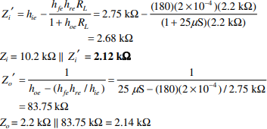
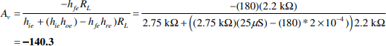
(b)
(c)
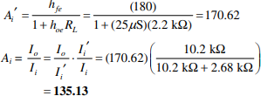

25.
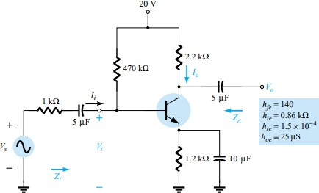
For the network of Fig. 8.83, determine:

(a) 𝑍′ = ℎ
= ℎ𝑓𝑒ℎ𝑟𝑒𝑅𝐿 = 0.86𝑘Ω − (140)(1.5𝑥10−4)(2.2𝑘Ω) = 0.86𝑘Ω − 43.79Ω = 816.21 Ω

𝑖 𝑖𝑒
1+ℎ𝑜𝑒𝑅𝐿
1+(25 µ𝑆)(2.2𝑘Ω)

𝑍_{𝑖} = 𝑅_{𝐵}||𝑍′ = 470 𝑘Ω ||816.21 Ω = 814.8 Ω
𝑖

- 𝐴
= −ℎ𝑓𝑒𝑅𝐿 = −(140)(2.2𝑘Ω)
= −𝟑𝟓𝟕. 𝟔𝟖

𝑣 ℎ𝑖𝑒+(ℎ𝑖𝑒ℎ𝑜𝑒−ℎ𝑓𝑒ℎ𝑟𝑒)𝑅𝐿

0.86𝑘Ω+((0.86𝑘Ω))(25 µ𝑆)−(140)(1.5𝑥10−4))2.2𝑘Ω

= 𝐼𝑂 = ℎ𝑓𝑒 = 140
= 132.70

𝑖 𝐼𝑖
1+ℎ𝑜𝑒𝑅𝐿
1+(25 µ𝑆)(2.2𝑘Ω)

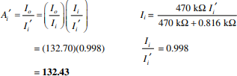

26.
(d) 𝑍_{𝑜}
= 1
ℎ𝑜𝑒−(ℎ𝑓𝑒ℎ𝑟𝑒/(ℎ𝑖𝑒+𝑅𝑠)
= 1
(25 µ𝑆)−((140)(1.5𝑥10−4))(0.86𝑘Ω+1𝑘Ω))
= 1
13.71µ𝑆
= 𝟕𝟐. 𝟗𝒌Ω

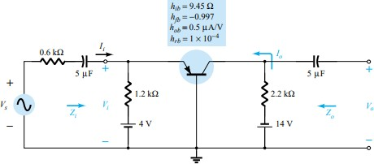
For the common-base amplifier of Fig. 8.84, determine:

(a) 𝑍′ = ℎ
− ℎ𝑓𝑏ℎ𝑟𝑏𝑅𝐿 = 9.45𝑘Ω − (−0.997)(1𝑥10−4)(2.2𝑘Ω) = 9.67Ω

𝑖 𝑖𝑏
1+ℎ 𝑅
𝐴 ( )

𝑜𝑏 𝐿
1+(0.5 µ
𝑉
) 2.2𝑘Ω

𝑍_{𝑖} = 1.2 𝑘Ω||𝑍′ = 1.2 𝑘Ω ||9.67 Ω = 9.59 Ω
𝑖

(b) 𝐴′ = ℎ𝑓𝑏 = 0.997
= −0.996

𝑖 1+ℎ 𝑅 𝐴 ( )

𝐼𝑜
𝑜𝑏 𝐿
𝐼′

1+(0.5 µ𝑉) 2.2𝑘Ω
1.2 𝑘Ω

𝐴_{𝑖} =
. ^{𝑖} = (−0.996)
′ 𝐼𝑖
𝐼
𝑖
1.2 𝑘Ω+9.67 𝑘Ω
= - 0.998

(c) 𝐴
= −ℎ𝑓𝐿𝑅𝐿 = −(−0.997)(2.2𝑘Ω)
= 𝟐𝟐𝟔. 𝟐𝟏

𝑣 ℎ𝑖𝑏+(ℎ𝑖𝑏ℎ𝑎𝑏−ℎ𝑓𝑏ℎ𝑓𝑏)𝑅𝐿

9.45Ω+((9.45Ω))(0.5µ𝐴/𝑉)−(0,997)(1𝑥10−4))2.2𝑘Ω

(d) 𝑍′ = 1 = 1

= 90.5𝑘Ω

𝑂 ℎ𝑎𝑏−[ℎ𝑓𝑏ℎ𝑟𝑏/ℎ𝑖𝑏] (0.5µ𝐴/𝑉)−((−0,997)(1𝑥10−4))/9.45 Ω
𝑍_{𝑜} = 2.2𝑘|| 𝑍′ = 2.15kΩ
𝑂
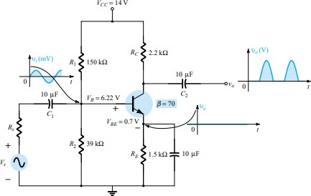
27.
Given the network of Fig. 8.85:
  - Determine if the system is operating properly based on the voltage-divider bias levels and expected waveforms for 𝑉_{𝑜} and 𝑉_{𝐸.}
  - Determine the reason for the dc levels obtained and why the waveform for 𝑉_{𝑜} was obtained.
- Using PSpice Windows, determine the gain for the network of Fig. 8.6. Use Probe to display the input and output waveforms.
- Using PSpice Windows, determine the gain for the network of Fig. 8.13. Use Probe to display the input and output waveforms.
- Using PSpice Windows, determine the gain for the network of Fig. 8.25. Use Probe to display the input and output waveforms.

